Name___________________________________.

|  |  |  |
| --- | --- | --- |
| Test part | Possible mark | Your mark |
| Multiple choice | 10 |  |
| Short answer | 44 |  |
| Total | 54 |  |

HUMAN BIOLOGICAL SCIENCE. YEAR 11. 2016.

Muscles, Bones and Joints.

***Multiple choice answer sheet.***

**Use a ball point or ink pen to mark an X** on the letter that represents the best answer from the choice of answers . Marks are not deducted for wrong answers.

|  |  |
| --- | --- |
| Question | Answer |
| 1 | A B C D |
| 2 | A B C D |
| 3 | A B C D |
| 4 | A B C D |
| 5 | A B C D |
| 6 | A B C D |
| 7 | A B C D |
| 8 | A B C D |
| 9 | A B C D |
| 10 | A B C D |

Multiple Choice

1. Which of these is the explanation of how muscles contract?   
a. Lock and Key Hypothesis   
b. Cell Theory   
c. Mendels laws   
d. Sliding filament model

2. Which of the following ions move into muscle fibres during muscle contraction?   
a.   Sodium   
b.  Calcium   
c.  Phosphate   
d.  Potassium

3. What are the actin and myosin filaments in muscle composed of?   
a. Nucleic acids   
b. Fatty acids   
c. Proteins   
d. Carbohydrates

4. The Matrix in cartilage tissue contians of which of the following materials?

a. Collagen.

b. Calcium Phosphate.

c. Calcium sulphate.

d. Adipose tissue.

5. All connective tissue contains which of the following?

a. A suspensor fluid.

b. A matrix.

c. A hard framework.

d. A set of unconnected cells.

6. The osteocytes in dense bone tissue are interconnected with each other by which of the following?

a. The Haversian system.

b. arteries.

c. veins.

d. Canaliculi.

7. One of the functions of the Periosteum is:

a. To provide a place of attachment for tendons.

b. To insulate the bone.

c. To reduce Friction.

d. All of the above.

8. Movement of the elbow joint can be:

a. Circumduction.

b. flexion and extension.

c. Abduction only.

d. Adduction only.

9. If the rate of osteoclast activity is much greater than osteoblast activity:

a. The bone will become less dense and much weaker.

b. The bone will become denser and much stronger.

c. The bone will become denser, yet more brittle.

d. The osteocytes will starve.

10. Which of the following is **not** a function of the skeletal system?

a. Storage of digestive enzymes.

b. Protection of internal organs.

c. Support against gravity.

d. Production of blood cells.

Short Answer Questions

1. Complete this table

|  |  |
| --- | --- |
| Word | Meaning |
| Muscle insertion |  |
| Muscle origin |  |
| Belly of muscle |  |

(3 marks)

1. Complete this table

|  |  |  |
| --- | --- | --- |
| Type of joint | Description | Example |
| Fibrous |  |  |
| Cartilaginous |  |  |
| Synovial |  |  |

(6 marks)

1. Here is a diagram of a synovial joint. Label it and then complete the table that follows.

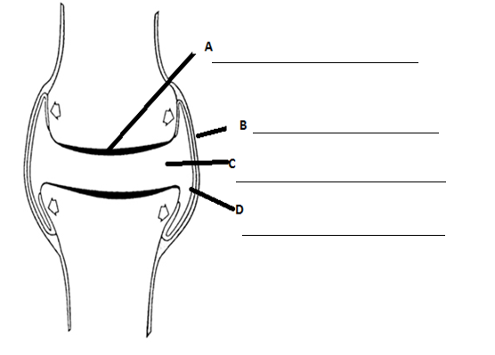

(2 Marks)

II.

|  |  |
| --- | --- |
| Structure | Function |
| A |  |
| B |  |
| C |  |
| D |  |

(4 marks)

III.

Which tissue in the previous diagram is damaged in Osteoarthritis?

_____________________________________________

(1 marks)

1. Use the diagram of microscopic bone structure below to complete the empty boxes in the table on the next page.

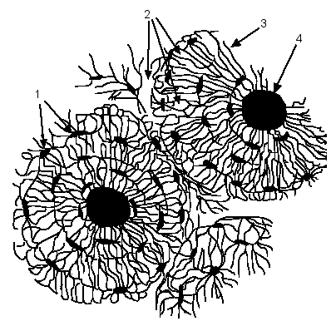

|  |  |  |
| --- | --- | --- |
| Label number | Name of part or material | Function |
| 1 | Osteocytes in Lacunae | Mature bone cells that maintain bone tissue. |
| 2 | Hard matrix |  |
| 3 |  |  |
| 4 |  |  |

(5 Marks)

1. Briefly describe what is happening in the diagram below.

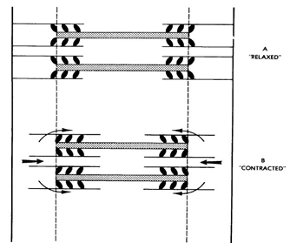

__________________________________________________________________________________________________________________________________________________________________________________________________________________________________________________________________________________________________________________________________________________________________________________________________________________________________________________________________________________________________________________________________________________________________________________________________________________________________________________________________________________________________________________________________________________________________________________________________

(5 marks)

1. Complete the table below.

|  |  |  |  |
| --- | --- | --- | --- |
| Diagram of joint | Name of Type of synovial joint | Describe Movement | Example |
| http://animatlab.com/portals/0/Images/AnimatLab/BallSocketType.gif |  |  |  |
|  |  |  |  |
|  |  |  |  |

(9 marks)

1. How is true circumduction different from the limited rotation seen in the neck?

____________________________________________________________________________________________________________________________________________________________________________________

(1 mark)

1. Look at the diagram below.

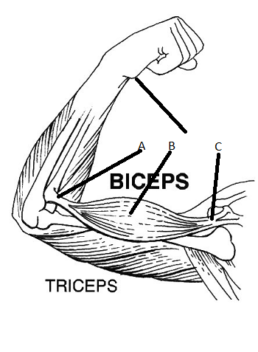

1. The two muscles working here are said to be antagonistic, what does this mean?

______________________________________________________________________________________________________________________________________________________________________________________________________________________________________

(1 mark)

1. = In this diagram the bicep is acting as the flexor, what does this mean?

__________________________________________________________________________________________________________________________________________

(2 marks)

1. Of the 3 letters labelled on the diagram, which represents the point of biceps insertion?

____________________________________________________________________________________________

(1 mark)

1. Hyaline cartilage is found on the ends of bones. It has elastic fibres arranged in matrix.
2. What is the matrix material called?

_______________________________

(1 mark)

1. Describe the arrangement of the elastic fibres in this type of cartilage.

__________________________________________

(1 mark)

1. The matrix has living cells embedded in it. What are these living cells called?

_________________________________________

(1 mark)

1. The outer ear is also made of cartilage, which type?

_____________________________________________

(1 mark)

End of Test